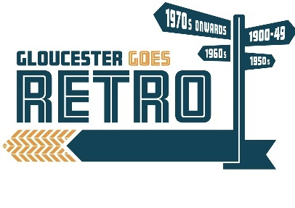
Gloucester Goes Retro
Classic & Historic Cars in the City
Application Form
Saturday 26th August 2023

Gloucester Goes Retro is back in Gloucester for 2023 with a fabulous display of vehicles as well and lots of entertainment.

We are looking for applications from Classic & Historic Vehicle owners of all types to take part in this retro showcase where the streets will be themed in different eras with shops & businesses joining in the fun.

With the magnificent Cathedral, Quays, Docks and plenty of shops & restaurants nearby there should be something for everyone! Join in the fun by dressing in your favourite retro outfit.

Music, fashion, living history and street entertainment from the eras all will play their part throughout this fun time, all culminating in awards for best dressed man, woman, couple, child and dog!

If you wish to attend please complete the form below & return with a photo if possible, send via email with these details to city.events@gloucester.gov.uk or by post to Gloucester Goes Retro, Gloucester Guildhall, 23 Eastgate Street, Gloucester, GL1 1NS.

Your booking will be confirmed in due course.
Name
Address
Post Code
Tel no.
E-mail
Vehicle.
Make/Year
Vehicle Registration
I confirm my vehicle is fully insured and legal and understand attendance is at my own risk.
Signature: Date:

